Homework 9: AE302, High-Speed Aerodynamics

Project: AE303, Experimental Aerodynamics

April 16, 2007

Question 1 and 2: due: April 23, 2007, beginning of class

Question 3-5 are part of the project report for the AE303 class

In a joint AE302/AE303 class on Thursday, April 24 (13.30), we will conduct an experiment in the SDSU Blow-Down tunnel. Wind tunnel tests will be performed on a diamond-wedge airfoil at a zero (run 1) and three degrees (run 2) angle of attack. The test is performed at a M₁=2 in the test section.

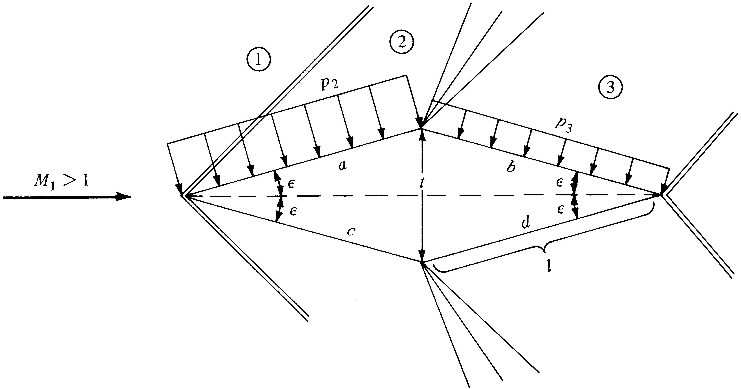

Other details of the setup are given as:
- The atmospheric pressure is p_{atm}=14.62 psi.
- Total pressure in the reservoir: p_{0,test} = p_{0,gauge} + p_{atm}= 29.65 +14.62 psi.
- Mach number in the test section is M_{test}=2
- The half angle of the airfoil is ε=8.5 degrees

Before we do the experiments we will prepare ourselves by quantifying the shock angle and the size of the expansion zone, and determining lift and drag on the airfoil using shock-expansion theory in Question 1 and 2 (an AE302 homework). In the AE303 project you will verify the theoretical analysis with the wind tunnel experiment. Further details will be provided by Prof. Conly.

Question 1: Determine the angle of the oblique shock wave using theoretical analysis for both runs. Determine the angle of the forward Mach line and the rearward Mach line of the expansion wave on the top of the airfoil for both runs.

Question 2: Determine the lift and drag on the airfoil for run 1 and run 2

Question 3: The half angle, ε, was measured with a large uncertainty. We can verify the accuracy of the ε measurement with measurements of the shock angle from the Schlieren photograph that will be emailed to you after the experiment. Determine the shock angle angle from the Schlieren photograph and then calculate the half edge angle that should give this shock. Compare ε determined this way to the measured ε.

Question 4: Pressure ports located on the wedge measure p₂ (port 13 and 14) and p₃ (port 15 and 16). In Table 1 four pressure measurements taken at different times are tabulated. Determine the average pressure and compare with the theoretically determined pressure in 2. Determine the standard deviation from the average in the pressure measurements. Give an explanation for the deviation.

Run 1
Port v13 | Port 14 | Port 15 | Port 16
-5.20429 | -6.45427 | -11.843 | -11.3336  Port 14  Port 15
-5.19238 | -6.43423 | -11.836 | -11.3233  Port 13  Port 16
-5.17094 | -6.40494 | -11.8275 | -11.3139
-5.18365 | -6.40956 | -11.8251 | -11.3147

Run 2
Port v13 | Port 14 | Port 15 | Port 16
-8.12196 | -9.54106 | -8.82605 | -9.21262
-7.97089 | -9.45849 | -8.64244 | -9.04817
-7.93233 | -9.4195 | -8.49277 | -8.91582
-7.92132 | -9.39962 | -8.47271 | -8.88763
Table 1. Port 13, and 14 measure the pressure in region 2 of figure 1. Port 15 and 16 measure the pressure in region 3 of figure 1.

The gauge pressures is measured at various positions in the converging-diverging nozzle leading to the test section. These pressure measurements are tabulated below.

Port 1 | Port 2 | Port 3 | Port 4 | Port 5 | Port 6 | Port 7 | Port 8 | Port 9 | Port 10 | Port 11
6.22369 | 2.82471 | -0.26499 | -4.14335 | -6.96699 | -7.27866 | -7.98461 | -8.2907 | -8.27575 | -8.5331 | -8.65857
6.32006 | 2.91617 | -0.1971 | -4.09134 | -6.93219 | -7.24341 | -7.94853 | -8.25828 | -8.25158 | -8.50313 | -8.63714
6.32301 | 2.91403 | -0.19491 | -4.08841 | -6.92784 | -7.23837 | -7.9442 | -8.25611 | -8.24846 | -8.50076 | -8.63078
6.20457 | 2.80041 | -0.28397 | -4.14701 | -6.97787 | -7.28297 | -7.98605 | -8.29574 | -8.2851 | -8.54098 | -8.66571
5.18273 | 1.91863 | -1.00812 | -4.65908 | -7.33677 | -7.62901 | -8.30644 | -8.59978 | -8.59071 | -8.82568 | -8.93717
Question 5:Determine A and the M number at each port. A*=4.5cm.

