Homework 1: AE302, Aircraft Propulsion Systems

September 11, 2007

Due: September 18, 2007, beginning of class

Problem 1: Chapter 2, problem 6

Problem 2: Chapter 2, problem 8

Problem 3:

A water jet is impinging on a curved surface as shown in the figure below. The water-jet mass flow rate is, , and it is exhausted through the nozzle at velocity, u, and it leaves the plate at angle, θ.

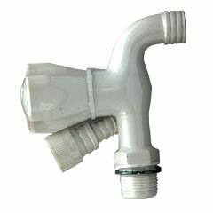
F_{x}
F_{y}
θ
p_{a}

. a) Assuming no friction losses and neglecting gravitational forces, derive a formula for the forces F_{x} and F_{y} at the base.
b) Calculate the magnitude of the force on the tap.
c) How much will this force change, when the turning plate is not present?

